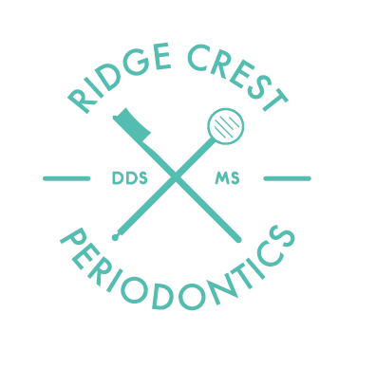

Written Financial Policy

Thank you for choosing Ridge Crest Dental Implants & Periodontics. Our primary mission is to deliver the best and most comprehensive dental care available. An important part of the mission is making the cost of optimal care as easy and manageable for our patients as possible by offering several payment options.
Payment Options:
You can choose from:
- Cash, Check, Visa, MasterCard, American Express or Discover Card
We offer a 5% courtesy adjustment to patients who pay for their treatment in full prior to or on the day of surgery. This adjustment applies only to treatment plans that exceed $500 or more.
- CareCredit Healthcare Credit Card or Greensky
These are both outside financing companies that allow you to apply for a loan. Once approved, you will be eligible to spread out your payments monthly. Carecredit offers a 6 and 12 month plan at no interest if paid in full within the promotional period and Greensky offers a 6, 12, 18 and 24 month plan at no interest if paid in full within the promotional period.
    - We also offer in-house financing, requiring a 25% down payment and up to 3 monthly payments by electronic withdrawal of funds through your checking or savings account, or by any major credit card.
For patients with dental insurance we are happy to work with your carrier to maximize your benefit and will directly bill them for reimbursement of your treatment.** However, please keep in mind that we never guarantee payment from any insurance company & stress that any quote of benefits is only an estimate. Any leftover balance will be patient/guarantor responsibility. If you have any questions, please do not hesitate to ask. We are here to help you get the dentistry you want or need.
Appointment Cancelation Policy:
Dr. Moulton will be looking forward to seeing you at your scheduled appointment time. Our team has made sure to reserve this time specifically for you, and Dr. Moulton has prepared for your treatment sometimes weeks in advance.
- When scheduling for treatment a $50 down payment will be required to secure your appointment time. This will be collected when scheduling and will go towards your total treatment costs.
- If there needs to be a schedule change please give our office at the very least a 72 hour notice. If our office is not notified within this time frame, then the $50 will be non-refundable. The $50 down payment is also non-refundable to patients who do not show up to their scheduled appointment.

Patient, Parent or Guardian Signature Date

Patient Name (Please Print)
**However, if we do not receive payment from your insurance carrier within 60 days, you will be responsible for payment of your treatment fees and collection of your benefits directly from your insurance carrier.

Dr. Ethan D. Moulton, DDS, MS • 2375 E. Sunnyside Rd. Suite C • Idaho Falls, ID, 83404
Phone: 208.522.6683 • Fax: 208.552.3085 • www.rcperio.com

